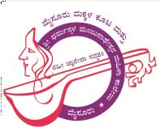
(Managedby:SDMESociety,Ujire)MysoreMakkalaKoota&
-
Krishnamurthypuram,Mysore-570004
Affiliated toUniversityofMysore, AccreditedbyNAACwithB GradeVision:“EmpowermentofWomentofacetheglobalchallenges”

Criteria 5

5.1.3c) Capacity building and skills enhancement initiatives taken by the institution include the following (10)
1. Soft skills, 2. Language and communication skills, 3. Life skills (Yoga, physical fitness, health and hygiene), 4. ICT/computing skills 2021 - 2022

Sl No. | Particulars | Link
1. | Life Skills Yoga, physical fitness, health and hygiene | https://sdmmmkmysore.in/docs/2024/june/Yoga-22-23.pdf

Phone:9886166750,0821-2332865Email:principal@sdmmmkmysore.inWebsite:sdmmmkmysore.in

